- FSM Mealy
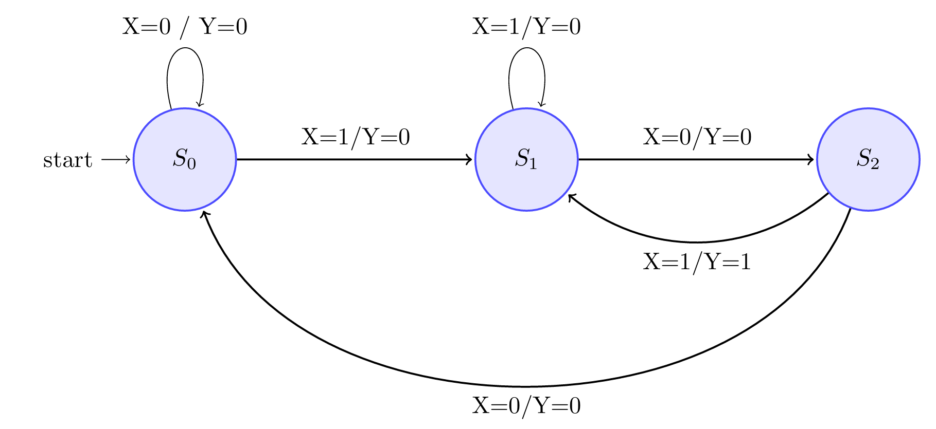

 | Next State / Output
 | X = 0 | X = 1
s0 | s0 / 0 | s1 / 0
s1 | s2 / 0 | s1 / 0
s2 | s0 / 0 | s1 / 1

TTHT |  |  | TTKT |  | Ngõ vào FF |  | Output
$$X$$ | $$Q_{1}$$ | $$Q_{0}$$ | $$Q_{1}^{+}$$ | $$Q_{0}^{+}$$ | $$D_{1}$$ | $$D_{0}$$ | Y
0 | 0 | 0 | 0 | 0 | 0 | 0 | 0
0 | 0 | 1 | 1 | 0 | 1 | 0 | 0
0 | 1 | 0 | 0 | 0 | 0 | 0 | 0
0 | 1 | 1 | X | X | X | X | X
1 | 0 | 0 | 0 | 1 | 0 | 1 | 0
1 | 0 | 1 | 0 | 1 | 0 | 1 | 0
1 | 1 | 0 | 0 | 1 | 0 | 1 | 1
1 | 1 | 1 | X | X | X | X | X
D1 = X’Q0
D0 = X
Y = XQ1
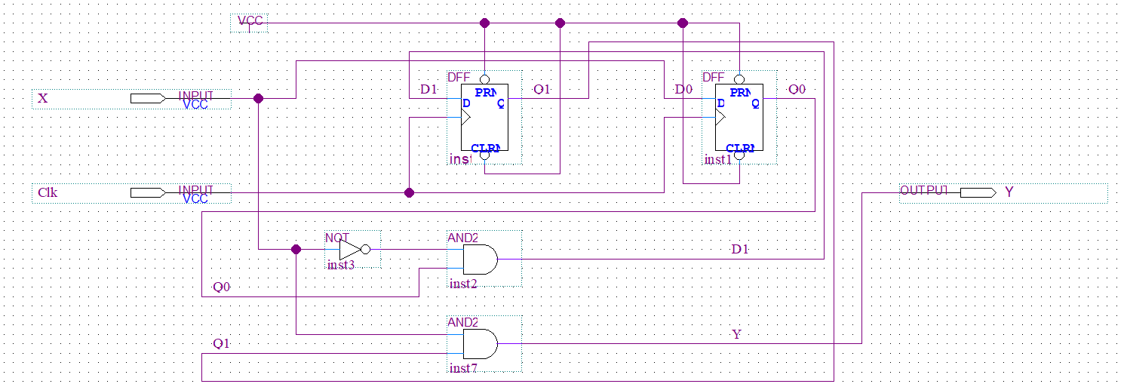
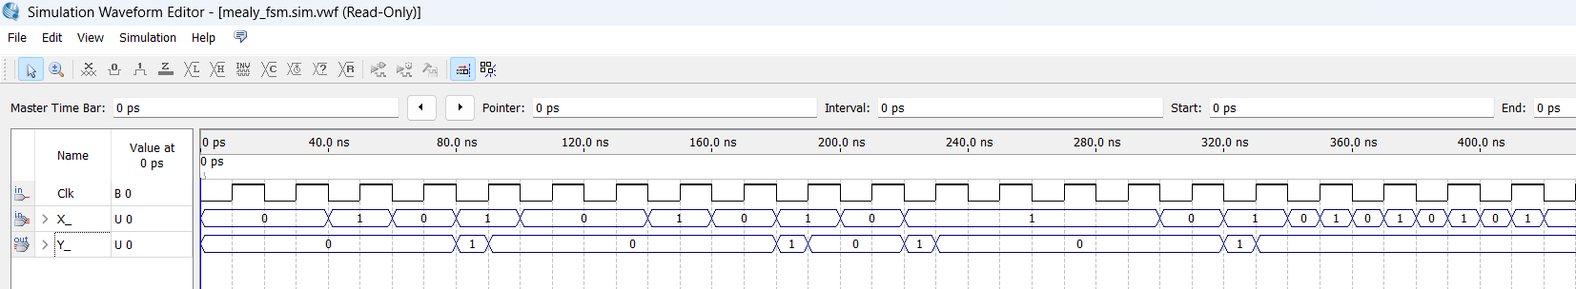
Sửa lại kiểu Mealy
- Moore
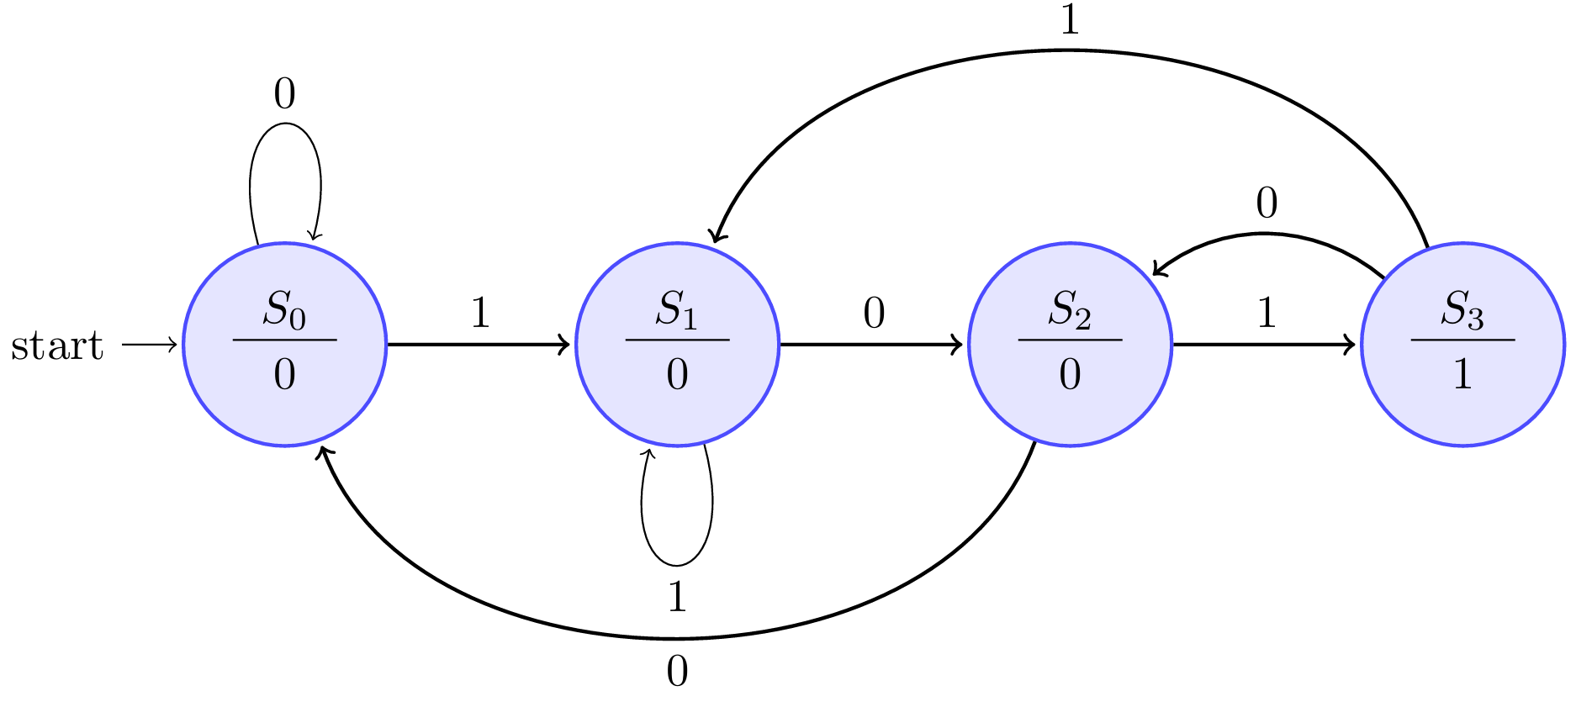

 | Next State |  | Output
 | X = 0 | X = 1 | Y
s0 | s0 | s1 | 0
s1 | s2 | s1 | 0
s2 | s0 | s3 | 0
s3 | s2 | s1 | 1

TTHT |  |  | TTKT |  | Ngõ vào FF |  | Output
$$X$$ | $$Q_{1}$$ | $$Q_{0}$$ | $$Q_{1}^{+}$$ | $$Q_{0}^{+}$$ | $$D_{1}$$ | $$D_{0}$$ | Y
0 | 0 | 0 | 0 | 0 | 0 | 0 | 0
0 | 0 | 1 | 1 | 0 | 1 | 0 | 0
0 | 1 | 0 | 0 | 0 | 0 | 0 | 0
0 | 1 | 1 | 1 | 0 | 1 | 0 | 1
1 | 0 | 0 | 0 | 1 | 0 | 1 | 0
1 | 0 | 1 | 0 | 1 | 0 | 1 | 0
1 | 1 | 0 | 1 | 1 | 1 | 1 | 0
1 | 1 | 1 | 0 | 1 | 0 | 1 | 1

D1 = X’Q0 + XQ1Q0’
D0 = X
Y = Q1Q0


